**PREPARATION INSTRUCTIONS**

**CO2 Resurfacing**

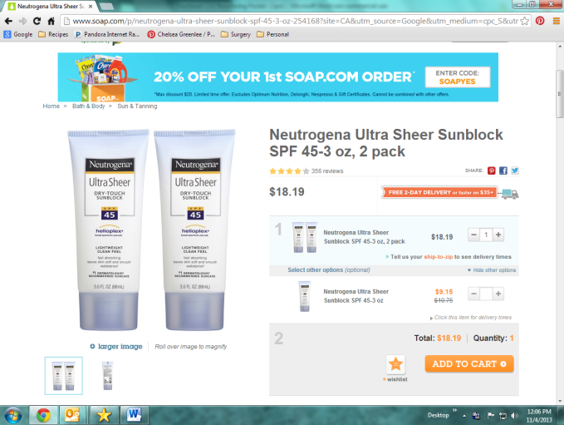**Items you will need:**

1. Sunblock Water Based Type (1st ingredient is Water) - Neutrogena Ultrasheer
2. 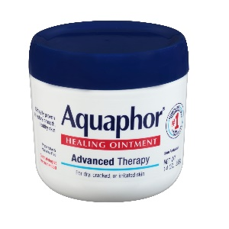Facial Cleanser- Cetaphil or Aquaphor gentle cleanser
3. Aquaphor healing ointment
4. Distilled water
5. Benadryl (for itching) and Tylenol (for pain)
6. Headband/ties to keep hair off the area treated
7. Bags of frozen peas or other soft/moldable ice packs

**Ten Days Prior**

1. We ask that you stop all over the counter blood thinning medications that were not prescribed by a doctor:
   1. Aspirin, ibuprofen, Aleve, Advil, , Excedrin, vitamins A, D & E, multi-vitamins, calcium +D, fish oil & garlic
2. If you take a blood thinner prescribed by a physician please inform Dr. Copperman and his office will coordinate stopping depending on the type of prescription

**One Week Prior**

1. Discontinue over the counter retinoid/BHA/AHA topical skin care products if you use them.
2. Practice using sunblock every morning.

**Two Days Prior**

1. Take one Valtrex 1000mg (prescribed) by mouth once a day.
2. Take one Bactrim DS or Cipro (prescribed) by mouth once a day.

**Day of Procedure**

1. Take the Diflucan 200mg (antifungal), Bactrim or Cipro (antibacterial), Valtrex (antiviral), and any thyroid, heart or blood pressure medications you regularly take with a small sip of water.
2. Wash your face but DO NOT WEAR ANY LOTIONS, SUNBLOCK OR MAKEUP.
3. Wear loose, comfortable clothing.
4. If you wear glasses, bring a case for storage. Do not wear contacts.

*Please see back for after surgery instructions*

**AFTER LASER CARE**

1. Wash your hands frequently and before each time you cleanse the treated area.
2. Cleaning your face
   1. **Day 1-3**
      1. Cleanse the face 2x day with a **vinegar/water solution** (1 Tbl white vinegar:1 C cool distilled water). Do not rub or scrub. Gently apply to skin.
      2. Apply thin layer (nickel size amount) of **AQUAPHOR** to the area after both times you have cleansed.
      3. Throughout the remainder of the day, you must apply the **AQUAPHOR** to keep the skin moist at all times. This is a very important step to the healing process.
   2. **Day 4 – Beyond** 
      1. Wash the resurfaced area (2) two times per day with your **GENTLE CLEANSER** and pat dry.
      2. Apply thin layer (nickel size amount) of **AQUAPHOR** to the area after both times you have cleansed.
      3. Throughout the remainder of the day, you must apply the **AQUAPHOR** to keep the skin moist at all times. This is a very important step to the healing process.
3. You may use cool compresses for 15min of the hour as needed. Avoid direct application of ice to skin. Recommend clean coldwash cloths or ice packs
4. Keep your head elevated for the first week after your procedure to minimize swelling. Sleep on 2 pillows or a wedge.
5. You may take Benadryl up to 3 times per day to reduce swelling and itching. It is recommended that you take this before bed as well, to minimize swelling overnight.
6. Remember to take the **full dose** of the antibiotics prescribed (Bactrim or Ciprofloxacin and Valtrex) until each prescription is finished.
7. At or around the end of the first week post-surgery, Dr. Copperman will instruct you to decrease the Aquaphor to bedtime and begin using your water-based sunblock and continue to use for at least three months. You may resume wearing makeup at this point as well.
8. Please call us if you experience: Temperature above 100.4, Yellowish discharge over the treated area, Pain that is not controlled with pain medication

No retinol or acid based skin products (Retin A/Retrinal, Glycolic, AHA/BHA, etc) for 4 weeks post treatment